**Feasibility study for starting a one stop discount auto shop in the Etobicoke borough of Toronto**

Shivaramkrishna Tadepalli

December 28, 2019

# Introduction

## Background

Canada is an auto nation. Residents of Toronto and its suburbs depend heavily on automobiles (cars, vans, SUVs and trucks) for travel and transportation. This leads to wear and tear of the automobiles and their tires. It makes business sense to start a one stop franchise that provides the following auto services and commodities at a discounted rate.

Oil change, servicing and repairs

Tires replacement

Auto body shop

It is advantageous to pick a location and analyze the feasibility of opening an auto shop in this location.

## Problem

Data that might contribute to determining a go/no go decision might include existing auto shops within a 5 km radius, services offered and frequency of customer visits.

This project aims to understand feasibility of starting a one stop auto shop franchise in the Etobicoke suburbs of Toronto

# Data acquisition and cleaning

## Data sources

The neighborhood data can be found at

<https://en.wikipedia.org/wiki/List_of_postal_codes_of_Canada:_M>

The geographic coordinates data can be found at <https://cocl.us/Geospatial_data>

I scraped ​ <https://en.wikipedia.org/wiki/List_of_postal_codes_of_Canada:_M>

for postal code, boroughs and neighborhoods and supplemented this with latitude and longitude data from <https://cocl.us/Geospatial_data>.

## Data cleaning

Data downloaded or scraped from the two sources were combined into one table. There were a lot of missing values for boroughs and these were dropped. Also, any updated neighborhoods and boroughs to be the same if a borough did not have a neighborhood assigned. I decided to only use neighborhood data for Etobicoke borough since that was my target market

## Category selection

After data cleaning, I used the Foursquare GET request url to get the top 100 venues within a 5 km radius. I grouped these venues by Category per neighborhood and then identified the top 10 common categories that were frequently used and visited by customers (See below)

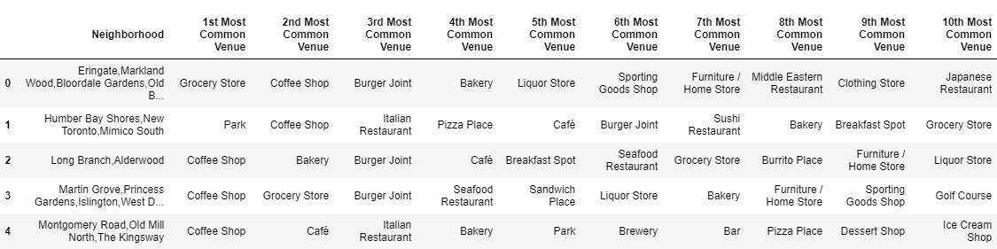

# Exploratory Data Analysis

## Analysis

If you review the above table you will find that there is no Auto shop that provides,

Oil change, servicing and repairs

Tires replacement

Auto body repairs and replacement

within 5 km radius of Etobicoke neighborhoods

# Predictive Modeling

## Clustering models

### Applying standard algorithms and their problems

I applied KMeans clustering using a sample set of 5 to support my analysis.

Results below

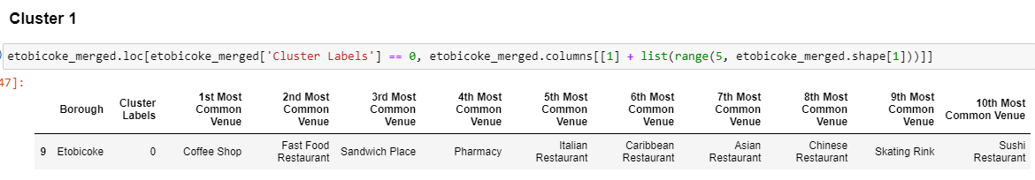

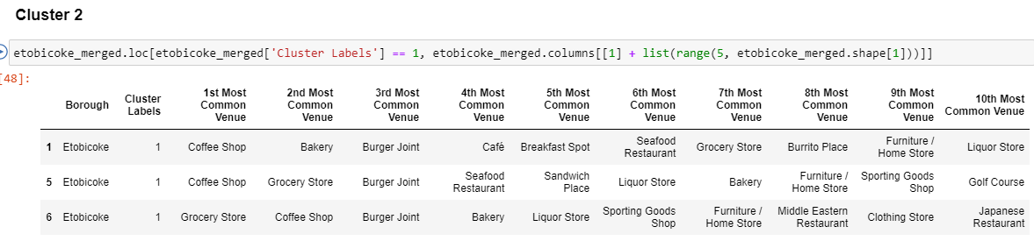

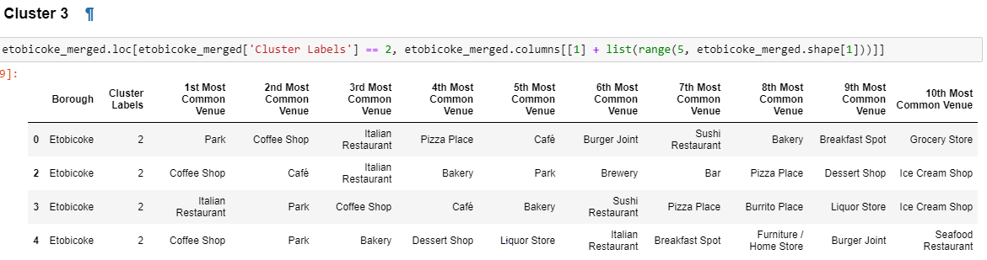

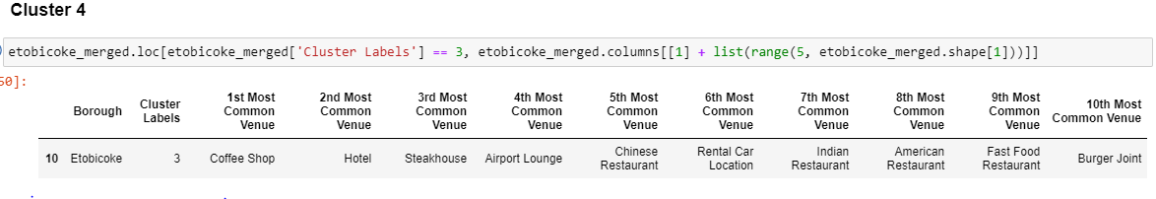

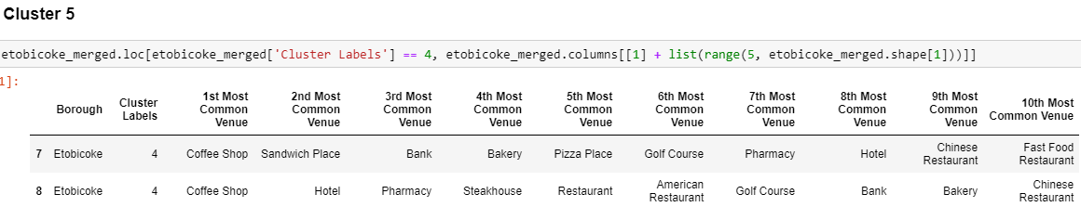

# Conclusions

In this study, I analyzed the neighborhood and geographical data for the Etobicoke borough of Toronto. Leveraged FourSquare API to group venues by category and identify the most common and frequently used venues and categories in the Etobicoke neighborhoods. Used KMeans clustering to confirm my findings. Based on this study it is feasible to open a one stop Auto Shop in the Etobicoke borough that provides following auto services and commodities at a discounted rate.

Oil change, servicing and repairs

Tires replacement

Auto body shop

# Future directions

Now that I have determined that it is feasible to open up a Auto shop franchise in Etobicoke next up are

Analyze automobile ownership data

Analyze pricing model